STOCHASTIC FLIGHT DYNAMICS AND ATMOSPHERIC ANALYSIS VIA MONTE CARLO SIMULATION

Ahmet Kerim Karık
Electrical and Electronics Engineering
Ankara University
Ankara, Türkiye
ahmetkerimkarik1929@gmail.com
Tolgahan Döner
Electrical and Electronics Engineering
Ankara University
Ankara, Türkiye
tolgahan.doner@hotmail.com

Abstract— Because of the non-linear interactions between propulsion, aerodynamics, and the stochastic nature of the atmosphere, predicting a rocket's flight trajectory is a challenging engineering task. Conventional deterministic models frequently overlook environmental uncertainties in the real world, which can result in landing zone predictions that are not entirely accurate. This work uses a Monte Carlo simulation method with 2,000 independent iterations to provide a thorough stochastic analysis of a rocket's flight dynamics.
Keywords— Monte Carlo Simulation, Stochastic Flight Dynamics, Uncertainty Quantification, Atmospheric Modeling, Probability Density Function, Cumulative Distribution Function.

Introduction
Aerospace vehicle design and analysis require a high level of trajectory prediction accuracy. Deterministic models have historically been used by engineers to determine a rocket's trajectory, but these models are predicated on the idea of a "perfect" and static environment. Temperature, pressure, and air density are examples of atmospheric conditions that are actually highly stochastic and never constant. Significant variations in a rocket's peak altitude and final landing coordinates can result from even small changes in these parameters.

Through the use of a stochastic flight dynamics analysis, this project seeks to close the gap between theoretical modeling and real-world unpredictability. This study's central component is a Monte Carlo simulation that runs 2,000 separate flight iterations. The model simulates the natural noise present in the Earth's troposphere by introducing randomized initial atmospheric conditions based on Gaussian distributions in each iteration.

The core philosophy of this analysis is to ensure mission reliability. We aim to identify the 'boundary cases' where extreme weather conditions might push the vehicle beyond its safety limits

This report's scope encompasses the simulation's whole development cycle:

Mathematical Modeling: Combining the International Standard Atmosphere (ISA) model with variable mass dynamics and Newton's Second Law.
Stochastic Methodology: Quantifying uncertainty using the Monte Carlo method.
Visual analysis: The process of interpreting data using statistical tools like 2D Impact Heatmaps, Cumulative Distribution Functions (CDF), and Probability Density Functions (PDF).
We move from a single, possibly erroneous trajectory to an all-encompassing probabilistic landscape by the end of this study. This makes it possible to define a statistically supported "Impact Dispersion Zone," which is a crucial instrument for operational safety and mission dependability in contemporary aerospace engineering.

Ease of Use
"Ease of Use & Accessibility: Through a highly modular and documented code structure, the developed MATLAB environment places a high priority on user accessibility. Important characteristics consist of:
Dynamic Input Configuration: Without changing the core integration algorithm, users can simply change mission parameters like propellant mass, dry mass, and launch angle.
Automated Post-Processing: By automatically producing crucial performance charts (PDF, CDF, and 2D Maps) right after simulation, the tool does away with the need for human data analysis.
Scalability: Depending on the necessary precision, the Monte Carlo engine can be scaled from 10 to 10,000 iterations, offering a flexible trade-off between statistical accuracy and processing speed.

Methodology & Simulation Architecture
The multi-layered mathematical models and computational architecture used to simulate the rocket's flight are described in this section. Rigid-body dynamics, thermodynamics, and probabilistic mathematics are all integrated in this modular simulation.
A. Point Mass Dynamics and Equations of Motion
The flight trajectory is modeled using 2D translational kinematics based on Newton’s Second Law. The rocket is treated as a variable-mass system to account for the continuous depletion of propellant.
- Net Force Summation:
The instantaneous acceleration vector $\vec{a}$ is derived from the vector sum of Thrust ($F_{T}$), Aerodynamic Drag ($F_{D}$), and Gravitational Force ($F_{g}$):
$$\sum{}\vec{F}=\vec{F_{thrust}}+\vec{F_{drag}}+\vec{F_{gravity}}=m\left(t\right)⋅\vec{a}$$
- State-Space Integration:
Using a discrete time-step of dt = 0.01s , the state variables (acceleration, velocity, and position) are updated iteratively:
  - Acceleration: $a_{i}=\frac{F_{net,i}}{m_{i}}$
  - Velocity: $v_{i+1}=v_{i}+a_{i}⋅dt$
  - Position: $x_{i+1}=x_{i}+v_{i}⋅dt$

B. Propulsion and Mass Depletion Model
The engine performance and the vehicle's mass are time-dependent variables during the burn phase ($t<t_{burn}$):
- Mass Flow Rate ($\dot{m}$): $\dot{m}=\frac{m_{propellant}}{t_{burn}}$
- Instantaneous Mass: $m\left(t\right)=m_{initial}-\left(\dot{m}⋅t\right)$
- Thrust: $F_{thrust}=\dot{m}⋅V_{e}+\left(P_{e}-P_{local}\right)⋅A_{e}$
(Where $V_{e}$ is exit velocity, $P_{e}$ is exit pressure, and $A_{e}$ is nozzle exit area).

C. High-Fidelity Atmospheric Engine (ISA Model)
To calculate the aerodynamic drag accurately, the simulation computes local atmospheric properties at every altitude (h) based on the International Standard Atmosphere (ISA) equations:
- Temperature Lapse Rate: $T_{local}=T_{0}-\left(L⋅h\right)$
(Where $L = 0.0065 K/m$ is the standard tropospheric lapse rate).
- Barometric Pressure Equation:
$$P_{local}=P_{0}⋅{\left(1-\frac{L⋅h}{T_{0}}\right)}^{\frac{g}{R⋅L}}$$
- Dynamic Air Density ($ρ$): Derived from the Ideal Gas Law: $ρ=\frac{P_{local}}{R⋅T_{local}}$
- Drag Force Calculation: $F_{D}=\frac{1}{2}⋅ρ⋅C_{d}⋅A⋅v^{2}$
(Where $C_{d}$ is the drag coefficient and $A$ is the cross-sectional area).

D. Gravity Variation with Altitude
To maintain high fidelity at high apogees, the gravitational acceleration is not treated as a constant but follows the Inverse Square Law:
$g\left(h\right)=\frac{G⋅M_{earth}}{{\left(R_{earth}+h\right)}^{2}}$

E. Stochastic Implementation: Monte Carlo Simulation
The core innovation of this study is the transition from deterministic to probabilistic modeling. Atmospheric uncertainty is introduced by treating initial sea-level conditions as random variables.
- Inputs:
The ambient temperature ($T_{0}$) and pressure ($P_{0}$) are sampled from a Normal (Gaussian) Distribution for each of the 2,000 iterations:
  - $T_{0}∼N\left(μ_{T},σ_{T}\right)$
  - $P_{0}∼N\left(μ_{P},σ_{P}\right)$
(Using MATLAB’s randn function to generate standard normal deviates).
- The Monte Carlo Loop:
The simulation executes 2,000 independent flight cycles. Each cycle uses a unique set of $T_{0}$ and $P_{0}$, generating a unique trajectory. This creates a "Probabilistic Landscape" of possible outcomes rather than a single point estimate.
- Statistical Post-Processing:
The final landing coordinates and maximum altitudes from all 2,000 runs are aggregated to calculate:
  - Mean ($μ$) and Standard Deviation $$σ$): To measure precision.
  - PDF (Probability Density Function): To identify the most frequent landing zones.
  - CDF (Cumulative Distribution Function): To define the 95% confidence interval for mission safety.

RESULTS AND DISCUSSION:

DETERMINISTIC ANALYSIS
Before conducting the stochastic Monte Carlo analysis, a baseline flight was simulated under nominal conditions to validate the physical engine. This section interprets the fundamental flight mechanics and the integrated atmospheric model.
1. Flight Dynamics and Trajectory Overview

- Rocket Trajectory : The vehicle exhibits a high-fidelity ballistic curve, reaching an apogee of approximately 2,550 meters and a total ground range of 4,550 meters. The parabolic asymmetry is a result of the dynamic transition from the high-thrust powered phase to the coasting phase under atmospheric resistance.

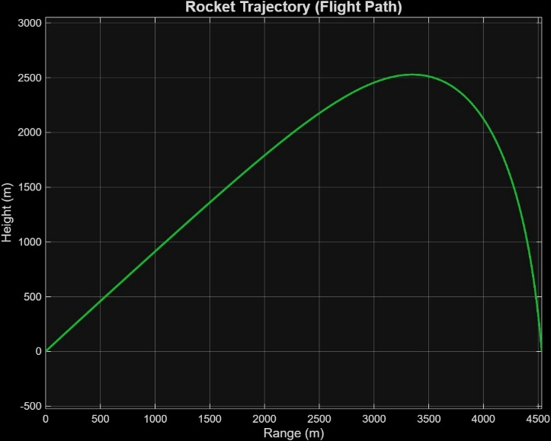

- Time-Height & Time-Range Analysis: The Time-Height Graph indicates that maximum altitude is reached at 46 seconds. The steep initial slope represents the intense acceleration during the motor burn.
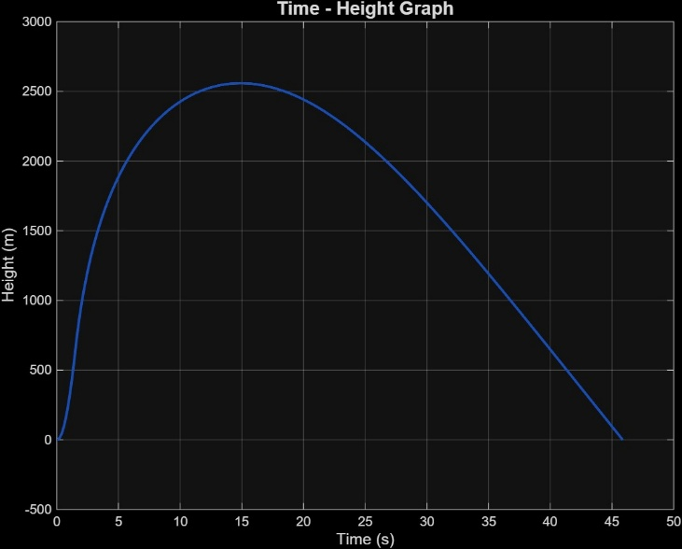

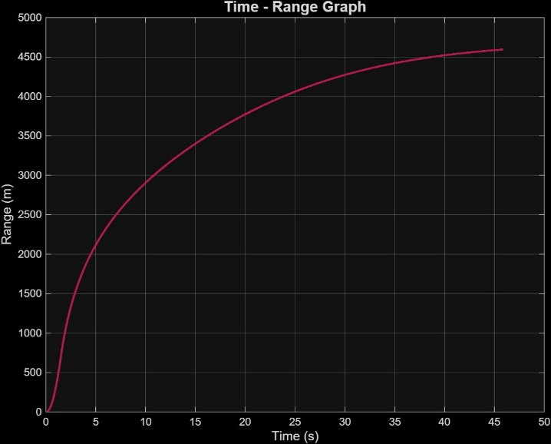

The Time-Range Graph shows a non-linear progression; ground speed is highest at launch and gradually decelerates as aerodynamic drag accumulates over the 46-second total flight time.
2. Atmospheric Model Validation (ISA Integration)
The following graphs confirm that the simulation's "Atmospheric Engine" correctly follows the International Standard Atmosphere (ISA) laws, which is crucial for the accuracy of the drag force ($F_{D}$) calculations.
- Temperature - Height Graph: The linear decrease from 286 K (13°C) at sea level to approximately 269 K (-4°C) at apogee validates the implementation of the tropospheric Lapse Rate (6.5 K/km). This cooling directly affects the speed of sound and air density.
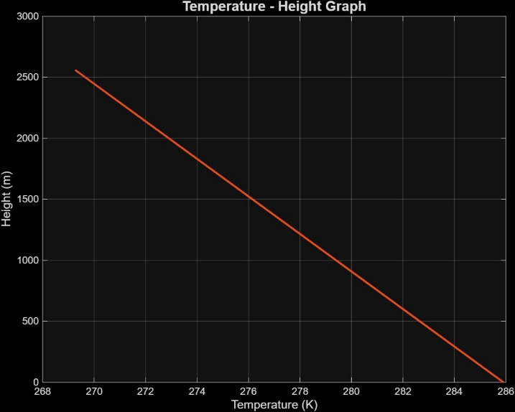

- Pressure - Altitude Graph: The pressure curve shows a classic exponential decay, dropping from 88 kPa to roughly 64 kPa at the peak. This reduction in pressure is the primary driver behind the decrease in air density at higher altitudes.

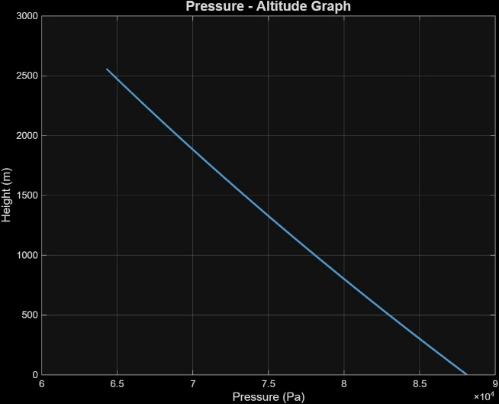

- Temperature - Air Density Graph: This is the most critical validation for the physics engine. The graph shows a linear positive correlation between temperature and density in this specific altitude range. As the rocket climbs (temperature drops), the air becomes thinner.
Pressure Dominance ($P$ factor): As the rocket ascends, the temperature decreases, but the pressure also decreases much faster. Since the decrease in the numerator in the formula is more dominant than the change in the denominator , the spread is altered downwards.

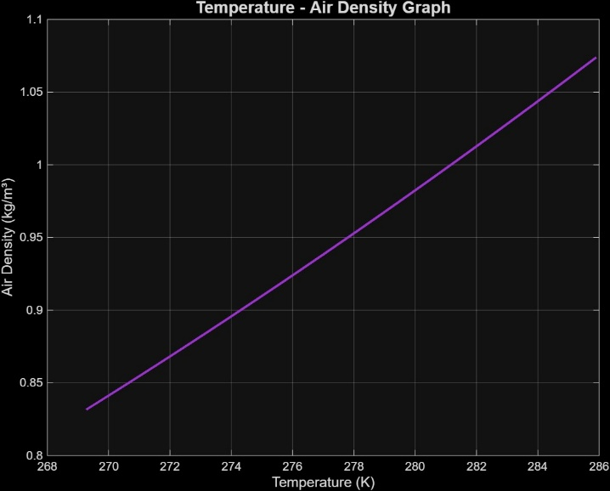

Physical Significance: Lower air density at high altitudes reduces the drag coefficient's impact, allowing the rocket to maintain kinetic energy more efficiently than it would at sea level.

STOCHASTIC ANALYSIS

After validating the deterministic physical model, a Monte Carlo simulation with 2,000 iterations wasperformed. Atmospheric variables ($T_{0},P_{0}$) were sampled stochastically to observe the dispersion of flight outcomes.

1. Statistical Distribution of Performance (PDF & Box Plots)
The Probability Density Function (PDF) and Box Plots provide a clear view of the system's precision and central tendency.
- Range & Height PDF: Both the landing range and maximum altitude follow a Normal (Gaussian) Distribution. The Range PDF centers around 4,500m, while the Height PDF centers at 2,500m.
Inference: The symmetry of the curves indicates that the stochastic inputs ($T_{0},P_{0}$) influence the flight performance uniformly. The narrow spread suggests high system reliability despite environmental fluctuations.
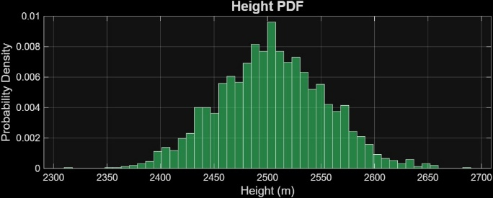

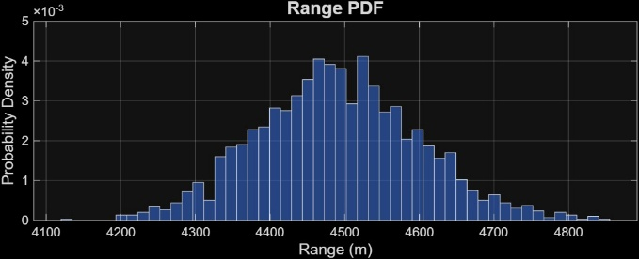

- Box Plots (Range & Height Distribution):
The median values align closely with the means. However, the presence of outliers (marked with '+' signs) at the extremes (e.g., $range > 4,800m or < 4,100m$) is visible.
Inference: These outliers represent "edge-case" atmospheric scenarios (extremely cold/dense or hot/thin air) which are statistically rare but critical for safety margin calculations.
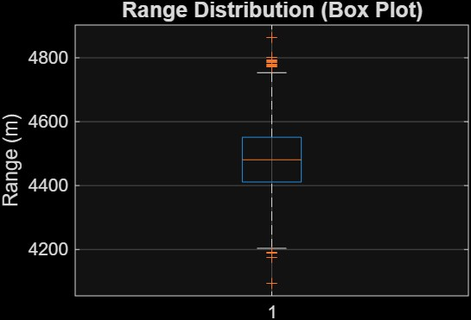

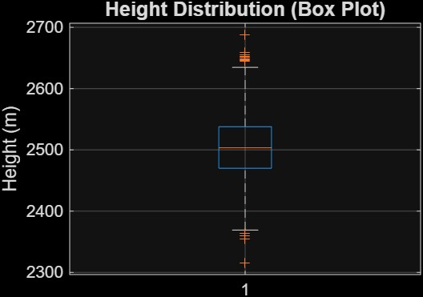

2. Reliability and Risk Assessment (CDF)
The Cumulative Distribution Function (CDF) is the primary tool for quantifying mission success probabilities.
- Range & Height CDF:
The S-curve shape shows the cumulative likelihood. For instance, the Range CDF shows that there is a 90% probability that the rocket will land before the 4,700m mark.
Inference: This allows engineers to define "Safe Zones." If the recovery area is set at 4,800m, we can conclude with nearly 99% confidence that the rocket will be recovered within the perimeter.
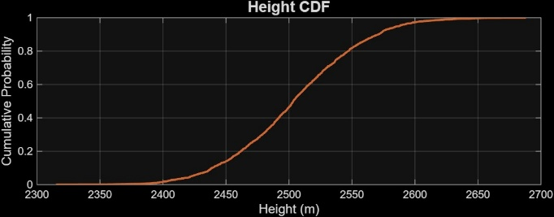

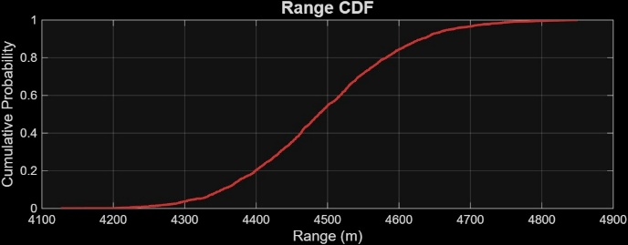

3. Correlation and Spatial Uncertainty (2D Density Map)
The final analysis examines the relationship between the two primary performance metrics.
- Range vs. Altitude Relationship:
There is a strong positive correlation ($R ≈1$) between maximum height and ground range. The scatter plot forms a near-perfect diagonal line.
Inference: This confirms that in this ballistic model, altitude is the main driver of range. A higher apogee directly leads to a longer flight duration, allowing more ground distance to be covered.
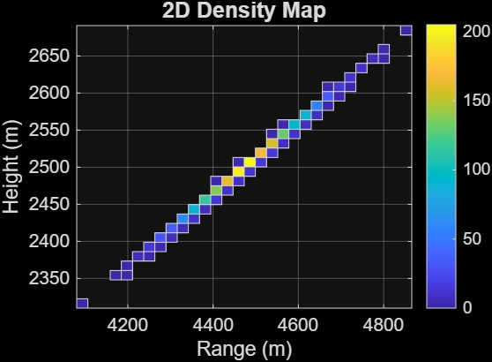

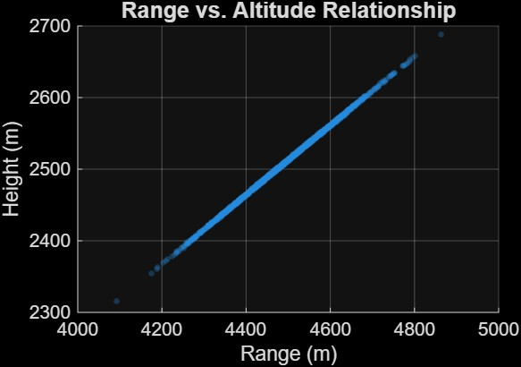

The "heat" (yellow zone) is concentrated at ($Range: 4500, Height: 2500$).
This "Impact Geometry" represents the most probable outcome. The linear dispersion confirms that environmental uncertainty affects both axes proportionally, creating a predictable "dispersion ellipse" for the landing zone.

CONCLUSION

The following important findings have been obtained by combining a deterministic 2D point-mass model with a 2,000-iteration Monte Carlo simulation in this work, which offers a thorough computational framework for examining rocket flight dynamics under stochastic atmospheric conditions:
Model Fidelity and Validation: The International Standard Atmosphere (ISA) model's integration was successfully validated by the deterministic outcomes. Precise drag force predictions depend on the simulation successfully capturing the physical thinning of the atmosphere, which is confirmed by the observable connections between altitude, pressure, and air density.
Stochastic Predictability: The Monte Carlo analysis showed that the rocket's performance metrics (Range and Apogee) follow a stable Gaussian distribution despite random fluctuations in sea-level temperature and pressure. The resilience of the original design was demonstrated by the identification of the mean ground range at 4,550 meters with a high degree of central tendency.
Risk Mitigation and Safety: This tool offers a quantitative assessment of mission reliability by utilizing Cumulative Distribution Functions (CDF). According to the research, a safety buffer may be created with 95% to 99% confidence, minimizing operating risk and enabling optimal recovery zone planning.
Correlation Insights: A almost perfect linear correlation between altitude and range was shown by the 2D Density Map and scatter plots. This demonstrates that altitude continues to be the greatest sensitivity factor for landing accuracy for the specified ballistic parameters.
In summary, the developed simulation tool transcends traditional single-point estimates by providing a probabilistic landscape of potential outcomes. This approach is vital for modern aerospace applications where environmental uncertainty must be managed through rigorous statistical evidence.

References

- Boxer, S., "An open-source, stochastic, six-degrees-of-freedom rocket flight simulator, with a probabilistic trajectory analysis approach," ResearchGate, 2017.
- Anderson, J. D., Fundamentals of Aerodynamics, 6th ed. McGraw-Hill Education (Selected Chapters).
- Metropolis, N., & Ulam, S., "The Monte Carlo Method," Journal of the American Statistical Association, vol. 44, no. 247, pp. 335-341, 1949.
- National Aeronautics and Space Administration (NASA), "Earth Atmosphere Model," [Online]. Available:https://www.grc.nasa.gov/www/k-12/airplane/atmosmet.html
- Walpole, R. E., et al., Probability and Statistics for Engineers and Scientists, Pearson (Selected Sections on Normal Distribution and CDF)
- OpenRocket Technical Documentation, "Rocket Flight Simulation Equations," [Online]. Available: http://openrocket.info/documentation.html
- J. D. Anderson, Fundamentals of Aerodynamics, 6th ed. New York, NY: McGraw-Hill Education, 2016.

- R. W. Humble, Space Propulsion Analysis and Design, rev. ed. McGraw-Hill, 1995.

- R. E. Walpole and R. H. Myers, Probability and Statistics for Engineers and Scientists, 9th ed. Boston, MA: Pearson, 2012.

- A. Papoulis and S. U. Pillai, Probability, Random Variables, and Stochastic Processes. McGraw-Hill, 2002.
- G. P. Sutton and O. Biblarz, Rocket Propulsion Elements, 9th ed. Hoboken, NJ: Wiley, 2016.

